1Day 1

Launching and Exposing the Container (ELK)
- Command: Sudo docker ps
- Screen shot: output results
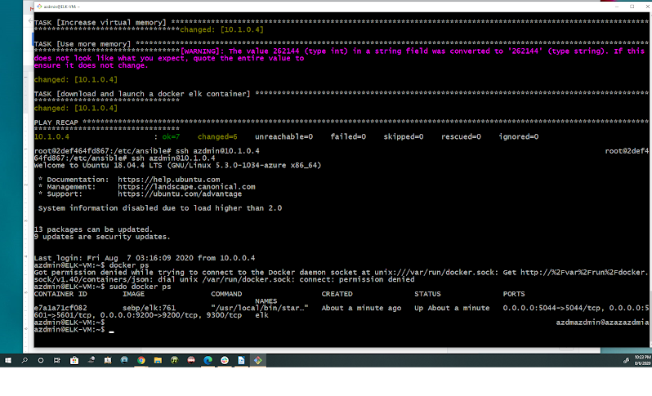

Identify and Access Management
- Screen shot: Access to Kibana server
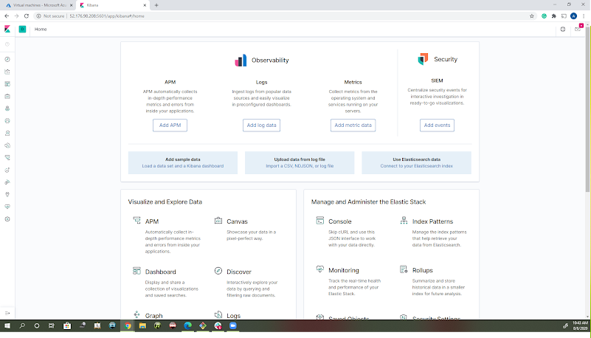

Day 2

Verifying Installation and Playbook
- Screen shot: Verify Incoming Data from File beat
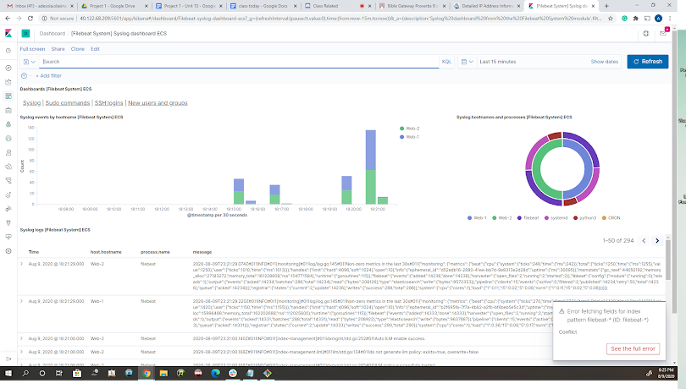
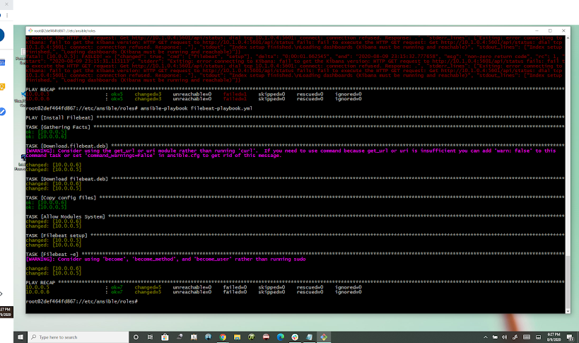
Bonus: Creating a Play to install Metricbeat (Side by Side view)

